Comparison of Prevalence Rates of Methicillin-Resistant Staphylococcus aureus of Hospital and Community Settings in Tropical and Temperate America: A Systematic Review and Meta Analysis
Jessica Budiselic
Amanda Kohler
Aashna Lala, MBA
Carlos Marbot
John Renzi
Shereen Sadlek
Yesenia Schmunk
Navrine Tahal
Steven Terry, MBA
Mentor: Dr. Birendra Tiwari , PhD, MSc.


ABSTRACT
Methicillin-resistant Staphylococcus aureus (MRSA) has become a leading cause of nosocomial and community-acquired infection due to pathogenic reactions, the most prevalent being impetigo, cellulitis, scalded skin syndrome, osteomyelitis, food poisoning. This systematic review and meta analysis investigates whether community-acquired (CA) and hospital-acquired (HA) S. aureus and MRSA in a tropical zone in America differs with respect to their prevalent sensitivity and antibiotic resistance when compared to temperate zones of America. For this research the Koppen climate classification system was used to define tropical zones having an average temperature above 18 °C and average relative humidity above 60%, and temperate zones having a range between -3 °C and 18 °C with variable RH depending on the season.¹
Data extraction of 30 articles sorted from 343 records and meta analysis of 14 articles present that MRSA is highly prevalent in USA (0.0731), moderately prevalent in Canada (0.0572) and Brazil (0.0466) while Mexico (0.0040), Peru (0.0051) and Argentina (0.0048) present lowest prevalence of MRSA in patients.
Likewise, the results presented in this systematic review and meta analysis show that S. aureus and MRSA carriage from nasal, throat and other swabs obtained from America present significant decline of MRSA prevalence from countries with tropical climate in comparison with the temperate zone of America.
This investigation may facilitate more prompt and effective action for the prevention and control of MRSA infections in tropical countries of the America. In particular, the use of MRSA screening based on rapid and reliable diagnosis during inpatient and outpatient admission of patients is crucial.

Keywords for this research:
Staphylococcus aureus, S. aureus, MRSA, tropical, Caribbean, antibiotic susceptibility, antibiotic, carriage

INTRODUCTION:
Staphylococcus aureus (S. aureus) has emerged as a very prevalent microorganism in the epidemiology of multiple diseases, the most prevalent being impetigo, cellulitis, scalded skin syndrome, osteomyelitis, food poisoning. S. aureus infections can occur in hospitalized patients as well as in the community, and the infections caused by Methicillin-resistant S. aureus (MRSA) strains have become particularly problematic.
Despite the potential threat of MRSA infections in tropical regions and the climatic adaptation associated of S. aureus, most information on MRSA infections has been documented from temperate countries. In tropical zones, a considerable knowledge gap exists in correlating MRSA variants and clones, such as the activation of mecA genes that encodes for PBP2a that enables cell wall synthesis in the presence of antibiotics, in respect to drug resistance and treatment protocols. B-lactams such as oxacillin and flucloxacillin are common drugs of choice for the treatment of Staph. infections. This is relevant to understand as it is the B-lactams that MRSA tends to be resistant to.² Based upon the research conducted, Vancomycin is currently the drug of choice for treating MRSA.³ Preliminary research was done in order to attempt to correlate the introduction of antibiotics into a region with drug resistance. Though not done at this time, it will be included in future updates in the development of this research.
The primary research question is that is there a statistically significant difference in prevalence rates of MRSA infections in tropical and temperate regions of the Americas? Secondly, is there a difference in prevalence rates of community associated and hospital associated strains of MRSA in tropical and temperate regions of the Americas? In order to answer these questions, this systematic review and meta analysis incorporates 30 studies on S. aureus and MRSA prevalence rates in hospital and community settings in the Americas. Both S. aureus and MRSA share optimum growth characteristics in that they favor warmer more humid climates with optimal growth characteristics of: temperature range of 25 °C to 37 °C^{4,5}, 55% to 75% humidity⁶, and a pH of 6.5 to 7.4.^{4,5} Since countries with warmer climates are more prone to the infection and less likely to contain MRSA, the division of tropical and temperate zones in the Americas present a unique insight towards epidemiologic implications of MRSA. This work also lacks correlation of S.aureus’s and MRSA’s Q10 Rule data which may provide deeper understanding and should be considered in future research. Owing to lack of similar research on the correlation between tropical and temperate climatic zones, this systemic review and meta analysis will prove as a milestone in S. aureus and MRSA research statistics. It will also form the foundation for future comparative research regarding S. aureus antimicrobial resistance and susceptibility in order to understand related phenomena across the globe.

History and Background
Staphylococcus aureus is a Gram-positive facultative anaerobe that can either grow aerobically; in the absence of oxygen by fermentation yielding lactic acid; or by using an alternative electron acceptor.⁷ S. aureus was discovered in 1880 when Scottish surgeon Alexander Ogston observed it in pus oozing from surgical abscesses.⁸ Humans are natural reservoirs of S. aureus that reside harmlessly on their skin, 10-20% of the human population all over the world are persistent carriers.⁹ Being an extremely impactful pathogen, S. aureus infections continue to pose a significant threat to the general health of humans and animals alike on a global scale. It can cause abundant skin and soft tissue infections, pneumonia, meningitis, endocarditis, and osteomyelitis². It can be found in all mammalian species, including humans and pets, often surviving on the skin, within the nostrils and sometimes may be observed along posterior nasopharynx.¹⁰
An epidemic is often ignited by the successful spread of a single S. aureus clone within a geographic region. Most commonly, S. aureus will spread in the healthcare setting and in the community as well. A prominent 6-year study conducted in Trinidad postulated that MRSA infection’s prevalence has increased over the years. Healthcare professionals’ hands have served as a prime source of Staphylococcal contamination. Sanitary practices, such as adequate hand hygienic measures, are recommended to control the spread of infections, especially in clinical settings. Staphylococcal species need to be countered by taking some necessary steps. Therefore, MRSA susceptibility pattern monitoring should be performed, and a newly formulated antibiotic policy should be developed.¹¹
Methicillin-resistant Staphylococcus aureus (MRSA) has become a leading cause of nosocomial and community-acquired infection due to nosocomial or community-acquired pathogenic reaction due to its resistance to methicillin and most related antibiotics. It is responsible for producing coagulase and catalase enzymes.¹² MRSA is a pandemic pathogen that spreads via various channels such as contaminated surfaces and airborne dissemination causing potentially life threating infections in the non-intact skin, bones, joints, surgical wounds, bloodstream, heart valves, urinary tract and lungs.¹³
MRSA began as a hospital-acquired infection and has evolved to community-acquired infections being found in animals, community centers, and day care settings.¹¹ Standard types of antibiotics (including the penicillins) can have little to no remedial effects on MRSA. Several factors may be involved in increasing prevalence of community-acquired MRSA. One set of factors for this increase may be the lateral dissemination of MRSA from hospital to the community in discharged patients diagnosed with MRSA. This is further accompanied by the discontinuation of therapy because of the high-cost of prescribed drugs at local pharmacies.¹¹
Accordingly, skin and soft tissue infections (SSTIs) associated with MRSA are the most common reasons for seeking medical care and MRSA hospitalization all over the world.^{14,15} It is reported that SSTIs hospitalizations have increased by 123% in the United States between 2001 and 2009 and the underlying health burden has also elevated due to the evolution of bacteria and increased antibiotic resistance. Further research based on 15 studies reported that worldwide S. aureus hospitalizations range between 13-74% cases associated with MRSA while European countries have seen a decrease in endemic rates of MRSA infections over the past decade.¹⁶ However, most of the world’s population which resides in the tropical regions are mostly developing or low-income countries of Latin America, East and Southeast Asia, tropical Australia and Pacific islands, the subcontinent of India, Pakistan, Middle Eastern countries and Africa¹. Hence, in terms of environmental effects on the growth of MRSA, there are not an abundant or productive amount of studies available in the literature. Furthermore, one extensive 18-month analysis in Odisha, India (a city with a tropical climate similar to Anguilla, BWI) concluded that an average weekly maximum temperature above 33° C coinciding with an average weekly relative humidity between 55% and 78%, is a favorable combination for the occurrence of S. aureus associated skin infections as well as MRSA infections.¹⁷ Resultantly, a higher burden of infectious diseases in addition to a lack of microbial diagnostic facilities hinder the understanding of MRSA and its dominant clones in tropical regions.¹⁸ Additionally, researchers associate warmer temperature settings in these regions to be responsible for the significant surge in MRSA infections in tropical regions. An indication towards seasonal nature complex interaction between host, pathogen, and environment causing MRSA infection has also shed light on the underlying tropical association of the prevalence of multiple dominant clones and variant isolates of MRSA in tropical countries.^{17,19-21} Incidentally in these regions, multiple antibiotic resistance has also become a major issue in developing optimum infection treatment protocols at hospitals.²² Hence, higher prevalence rates of MRSA infections in warm temperature may be associated with conducive environmental settings that promote bacterial proliferation and spread of infections.^{22,23}

METHODS
This systematic review and meta analysis was conducted according to PRISMA²⁴ guidelines to ensure that the research is reported consistently, transparently, and most importantly repeatable.

Search Strategy
Countries were divided into tropical and temperate zones as per the Köppen-Geiger climate classification system¹.The search was conducted using a custom R program based on the ‘RISMED’ package to extract paper titles. The PubMed data base was searched for papers using the key words MRSA or Methicillin-resistant Staphylococcus aureus and the name of the country. The R program produced a list of titles containing key words.

Inclusion and Exclusion Criteria
Peer-reviewed articles (written in English) published from January 2000 to January 2018 on MRSA prevalence within community and healthcare settings were evaluated. The titles and abstracts were screened by the authors independently for possible inclusion and exclusion criteria listed in Table 1. The full-text evaluation was conducted to report articles that included prevalence rates of S. aureus and MRSA in community or healthcare settings in the tropical and temperate countries of American continents. Inconsistencies and any disagreements were resolved by consensus.

Inclusion | Exclusion
- Studies published from January 2000 to January 2018 were included in the search.  - Studies reporting S. aureus and MRSA carriage from nasal/fecal/lesion/blood or any other specimens from humans.  - Observational studies providing information on the prevalence, frequency or proportion of S. aureus and MRSA in the tropical and temperate countries in the America.  - Studies using the standard method for S. aureus and MRSA detection and following the CLSI guidelines for the diagnosis: minimum inhibitory concentration (MIC) measurement via broth microdilution, agar dilution, E-Test, desk diffusion, mecA gene test via PCR. | - Articles limited to the number of isolates from various specimens and lacking demographic data of the humans involved in the study.  - Studies screening a preselected group of participants and presenting nonrandomized microbiological assessment.  - Studies with non-standard methods, studies with high risk of bias, non-human studies, review articles, congress abstract and systematic reviews.  - Studies not defining the healthcare exposure data: Out-patients, In-patients, healthcare personnel, healthy participants etc.  - Studies published in languages other than English.

Table 1: Eligibility Criteria for the Systematic Review and Meta Analysis

Study Selection and Characteristics
The study selection process follows the PRISMA protocols and retrieved 305 records from the PubMed database search (tropical 136, temperate 169) and an additional 38 (tropical 23, temperate 15) records were also obtained through Google Scholar search. After eliminating duplicates, the papers were screened based on titles and irrelevant papers eliminated. In a secondary screening, 76 of the articles were excluded on the basis of title screening followed by abstract screening (Figure 1).
After gathering a unique list of articles, they were downloaded and screened for inclusion and exclusion criterion. However, a vast majority (173) of these records were excluded because those papers did not document demographic information of the patients admitted at the time of screening.
Moreover, (45) articles were excluded because they illustrated case studies instead of statistical data on the carriage and virulence of the S. aureus. Consequently, 30 articles were selected for systematic review and 14 were selected for the meta analysis.
The geographic location of the studies covered North, Central, and South America and analyzed studies from Brazil, Colombia, Ecuador, Mexico, Panama and Peru in the tropical regions in addition to the USA, Uruguay, Chile, Canada and Argentina in the temperate regions. All included studies used standard diagnostic tools for the detection of MRSA infection and isolates. MRSA was mainly isolated from nasal swabs, however, some studies also included carriage from wounds, blood, urine, sputum, and throat, etc.

Quality Assessment
The quality of the 30 articles was checked independently by the authors using the GRADE system.²⁵ This system allows for a consistent scoring of each article for evidence, quality, consistency, directness and effect size. The scoring was done on a 5-point scale from -1 to 3 including zero. The total score was calculated, and high scoring articles were chosen for further analysis.
Figure 1. PRISMA Study Selection Protocol.

Data Extraction
Data extraction was performed, and the results were tabulated in a standard data extraction form. Data extraction variables included the country, year of publication, number of investigated cases, number of participants, their demographic data, S. aureus and MRSA isolates, sample collection and diagnostic method, frequency and the percentage of S. aureus and MRSA.

Statistical Analysis and Data Visualization
The MRSA prevalence rates were calculated using Microsoft Excel. R STUDIO (V1.1.38) was used for performing meta analysis. Data was loaded into a .csv file and pooled estimates of prevalence rates were calculated using the fixed effect and random effects model. The algorithms defined by the ‘Metafor’ package was used for analysis. The Cochrane Q-test²⁶ and I² ²⁷ values were used to estimate the heterogeneity in data. The criterion for the significance for the test of heterogeneity was set to α=0.05. A funnel plot was constructed to determine publication bias among the selected studies.
To obtain genotype statistics of MRSA colonization from human specimens, several techniques have been used including Chromogenic Candida Agar isolation, multilocus sequence typing (MLST), pulsed-field gel electrophoresis, staphylococcal cassette chromosome mec (SCCmec), polymerase chain reaction (PCR) with several genotypes such as spa, sbe, eap, acrA, femB etc.
Most studies screened virulence genes using PCR techniques. Out of the seven countries reviewed in this research, Brazil reported prevalence of SCCmec Type I, III, IV, and V; Bolivia reported prevalence of SCCmec IV; Colombia reported SCCmec I and IV; Ecuador reported SCCmec II, III; and IV Peru reported SCCmec IV while studies from Mexico and Panama quoted information on genotype and virulence. Among these countries, SCCmec III was recorded in most studies along with SCCmec IV which represent CA-MRSA and HA-MRSA respectively (Table 2).
In the case of temperate countries, the USA reported prevalence of SCCmec II, IV, and V; Argentina reported SCC mec IV and V; Canada reported SCC II, III, and IV while studies from Chile and Uruguay did not quote information on SCC mec type. Among these countries, CA-MRSA with SCCmec IV is reported in most case and the occurrence of HA-MRSA is lower (Table 2).
RESULTS
Genotyping was performed in (66.7%; 10/15) of tropical countries and (53.3%; 8/15) the temperate zone countries. PCR detection of SCCmecA was most commonly employed in tropical (70%; 7/10) settings while PFGE was exclusively used in countries in temperate settings (100%; 8/8).
Less than half of the studies reported using PCR detection of the PVL genes; tropical countries (7/15; 46.6%) and temperate countries (6/15; 40%). Accordingly, most of these studies also reported PVL negative strains in tropical countries while most countries in temperate zone reported PVL positive MRSA strains. Also, most CA-MRSA isolates were PVL positive in comparison to HA-MRSA in both zones. However, the discrepancy was observed when the mixed population of inpatient and outpatient specimens were considered in the studies where several isolates were recognized and PVL negative.
 | SCC mec I | SCC mec II | SCC mec III | SCC mec IV | SCC mec V
Brazil | ✓✓ |  | ✓✓✓✓ | ✓✓✓ | ✓
Bolivia |  |  |  | ✓
Colombia | ✓ |  |  | ✓
Ecuador |  | ✓ | ✓ | ✓
Mexico
Panama
Peru |  |  |  | ✓
United States of America |  | ✓ |  | ✓✓ | ✓
Argentina |  |  |  | ✓ | ✓
Chile |  |  |  | ✓
Uruguay
Canada |  | ✓ | ✓ | ✓

Table 2: Types of MRSA Isolates Reported in the Studies

MRSA Carriage Rates According to the Demographic Conditions
From the results obtained from the systematic review, it is observed that in general men were more susceptible to MRSA colonization in comparison to women. Children and the elderly were more susceptible to MRSA infection than the adult population in the tropical zone while the elderly and adult population were reportedly more susceptible to MRSA carriage than neonates and children in temperate countries.
While this study includes demographic analysis of mostly hospitalized inpatients or out patients, few cases of healthy subjects have also been reported. For example, Carvalho et al. reported a 7.6% MRSA prevalence rate in healthy daycare children who were not previously hospitalized.²⁸ Bartoloni et al. presented another study involving urban and rural settings and reported that a rural village in Bolivia was the only location where the researchers detected MRSA carriage²⁹.
Highest MRSA nasal carriage rates were reported at 47% in a population study in the USA while several studies failed to report this data to draw conclusions. However, the average nasal carriage rate in tropical countries was observed to be 1.11% and 16% in temperate countries. Ergo, it may be concluded that studies included in this review show a bias in terms of nasal carriage and the skew is presenting a vast difference in this context.

Pooled Estimates of Carriage Rates Assessed by Meta Analysis
Out of the 30 studies used for the systematic review only 14 (4 temperate and 10 tropical) were used to conduct the meta analysis.
Studies included in the meta analysis were tested for heterogeneity using Cochrane Q test and I² statistics. Studies included in all of the proportional meta analyses were heterogeneous. The symmetric nature of the funnel plot showed that small study bias yielded insignificant effects (Figures 4, 6, 9).
The MRSA prevalence in tropical and temperate countries of America was investigated using the fixed effects and random effects model. MRSA prevalence ratio in tropical countries was 40% (z-value: 39.7, p-value<0.0001) while temperate countries presented 20% (z-value:108, p-value < 0.0001) prevalence rate as per fixed effects model. Random effects model showed 40% (z-value:4.6, p-value < 0.0001) and 20% (z-value:2.81, p-value < 0.0049) for tropical and temperate countries respectively.
One-tailed z test was used to compare whether the prevalence rate in tropical area is higher than that in temperate ones. There is a significant difference in prevalence rates of MRSA in tropical and temperate regions (Z=1.7, P-value=0.044). However, there is no significant difference in the prevalence rates of HA MRSA (Z = -1.1309, P-value= 0.1291) and CA MRSA (Z=1.03, P-value=0.1515) in tropical and temperate regions (Table 3).
 | MRSA Trop vs. Temp | CA MRSA | HA MRSA
Tropical | 0.396 (SE 0.086) | 0.151 (SE 0.0223) | 0.4109 (SE 0.1079)
Temperate | 0.2043 (SE 0.0727) | 0.2704 (SE 0.1032) | 0.2531 (SE 0.1087)
Difference | 0.1917 | -0.1194 | 0.1578
Variance | 0.0127 | 0.0111 | 0.0235
z Statistic | 1.7023 | -1.1309 | 1.0303
P Value | 0.0446 | 0.1292 | 0.1515
Significant | Yes (0.05 significance level) | No (0.05 significance level) | No (0.05 significance level)
Table 3: Comparison of Prevalence Rates
MRSA Prevalence Rates According to the Country
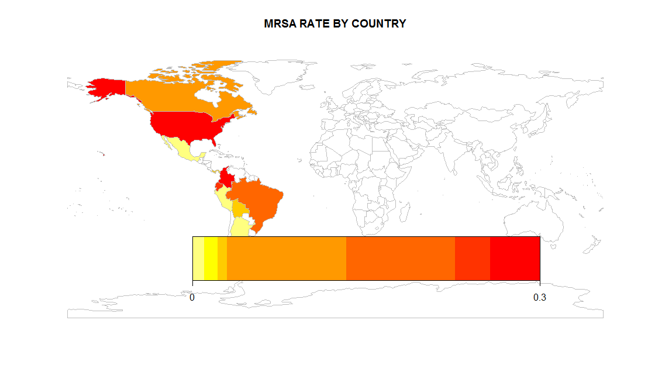
As per the statistical analysis and the maps illustrated in Figure 2 through Figure 16 and they’re accompanying tables, it is demonstrated that MRSA is highly prevalent in the USA (0.0731), moderately prevalent in Canada (0.0572) and Brazil (0.0466) while Mexico (0.0040), Peru (0.0051) and Argentina (0.0048) present lowest prevalence of MRSA in patients. Among these countries, community-acquired MRSA is common in most regions except Mexico, Peru, Argentina and to some extent Bolivia (0.0179) and Colombia (0.023802232). Correspondingly, hospital-acquired MRSA is more prevalent in Canada (0.182637), Bolivia (0.0179), and Argentina (0.001965), while U.S.A (0.286) and Brazil (0.2511) present more prevalence of HA-MRSA.

Figure 2: MRSA Prevalence Map/ Tropical vs. Temperate

 | USA | Canada | Brazil | Ecuador | Colombia | Bolivia | Panama | Peru | Argentina | Mexico
Avg. Prev. | 0.0731 | 0.0572 | 0.0466 | 0.0238 | 0.0238 | 0.0179 | 0.0132 | 0.0051 | 0.0048 | 0.0040
# Screened | 35935207 | 254900 | 4289 | 342 | 688 | 280 | 379 | 585 | 47329 | 500
# S.aureus | 1517471 | 1482 | 695 | 132 | 469 | 41 | N/A | 146 | 1219 | 210
Table 4: Mean Prevalence Rates/ Tropical vs. Temperate

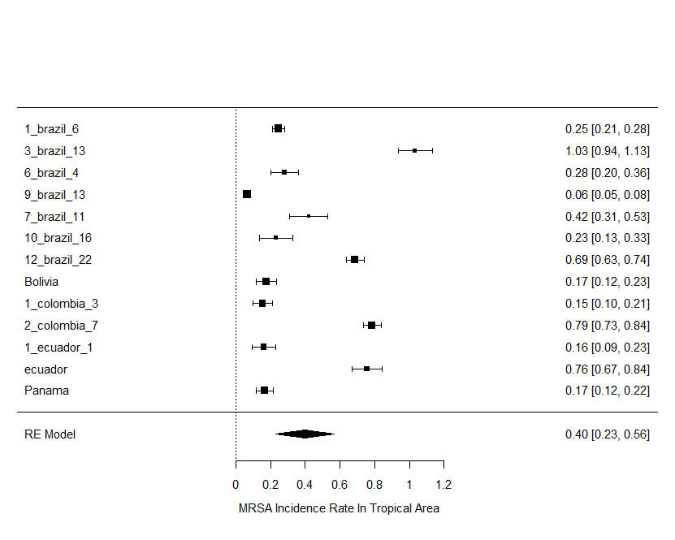 | 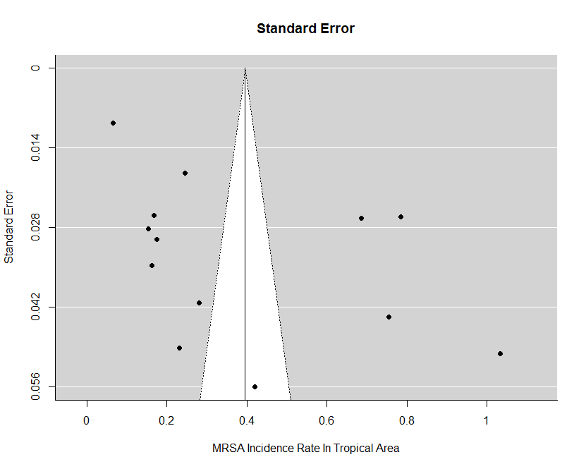
Figure 3: MRSA Prevalence Tropical | Figure 4: MRSA Prevalence Tropical
Fixed-Effects Model (k = 13)
Test for Heterogeneity:
Q (df = 12) = 1502.3198, p-val < .0001
Model Results:
estimate se zval pval ci.lb ci.ub

0.3970 0.0100 39.7436 <.0001 0.3774 0.4166 ***
Random-Effects Model (k = 13; tau^2 estimator: REML)
tau^2 (estimated amount of total heterogeneity): 0.0949 (SE = 0.0393)
tau (square root of estimated tau^2 value): 0.3081
I^2 (total heterogeneity / total variability): 99.30%
H^2 (total variability / sampling variability): 143.81
Test for Heterogeneity:
Q (df = 12) = 1502.3198, p-val < .0001
Model Results:
estimate se zval pval ci.lb ci.ub

0.3960 0.0860 4.6033 <.0001 0.2274 0.5646 ***
Table 5: Mean Prevalence Rates Tropical
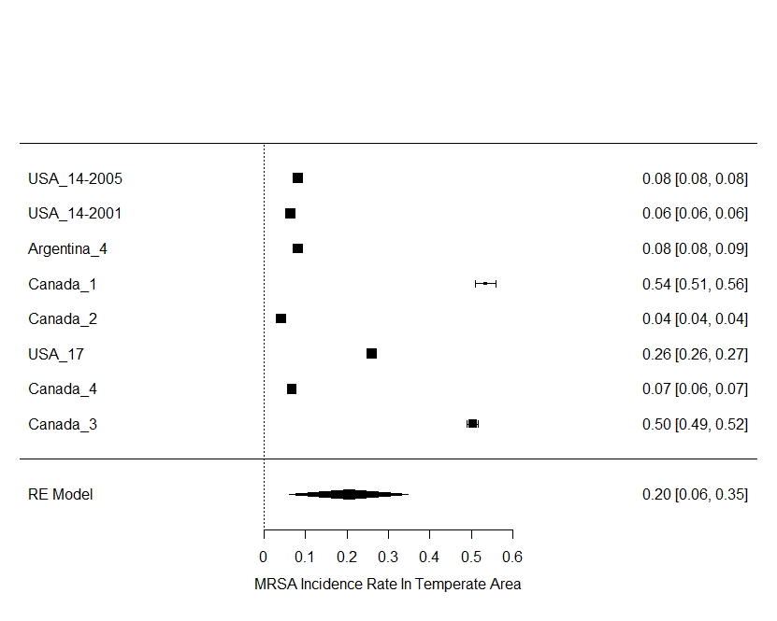 | 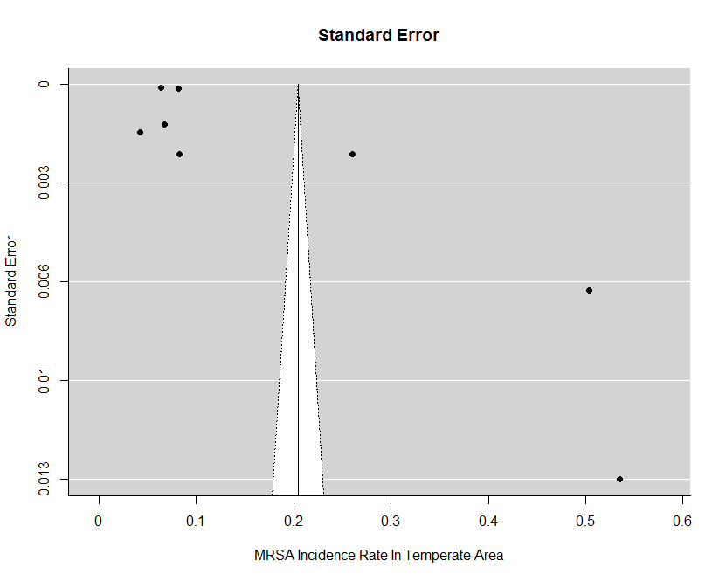
Figure 5: MRSA Prevalence Temperate | Figure 6: MRSA Prevalence Temperate
Fixed-Effects Model (k = 8)
Test for Heterogeneity:
Q (df = 7) = 23688.7189, p-val < .0001
Model Results:
estimate se zval pval ci.lb ci.ub
0.2045 0.0019 108.0571 <.0001 0.2008 0.2082

Random-Effects Model (k = 8; tau^2 estimator: REML)
tau^2 (estimated amount of total heterogeneity): 0.0423 (SE = 0.0226)
tau (square root of estimated tau^2 value): 0.2056
I^2 (total heterogeneity / total variability): 100.00%
H^2 (total variability / sampling variability): 443073.72
Test for Heterogeneity:
Q (df = 7) = 23688.7189, p-val < .0001
Model Results:
estimate se zval pval ci.lb ci.ub
0.2043 0.0727 2.8103 0.0049 0.0618 0.3468

Table 6: Mean Prevalence Rates Temperate

Tropical CA MRSA Rate
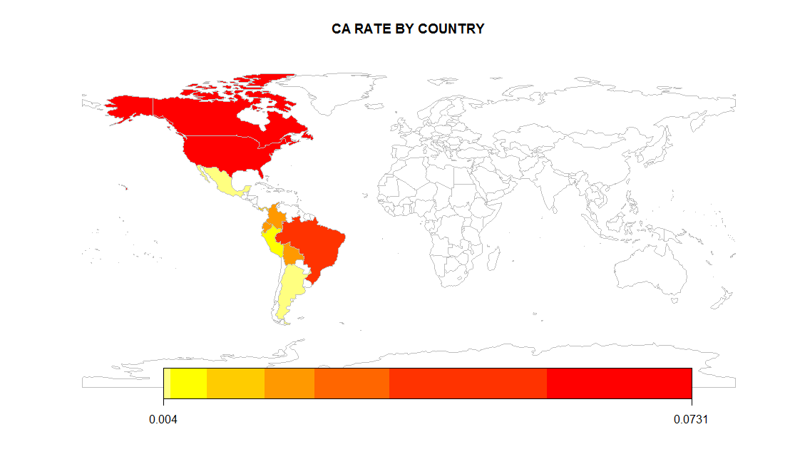
Community acquired MRSA prevalence rate was also analyzed in the meta analysis wherein the fixed effects model showed 16% (z-value:17.2, p-value < 0.0001) (CI) prevalence rate for tropical countries and 27%(z-value:54, p-value < 0.0001) (CI) for temperate countries. The random effects model quoted 15% (z-value:6.77, p-value < 0.0001) and 27% (z-value:2.61, p-value: 0.0088) for tropical and temperate countries respectively.

Figure 7: CA-MRSA Prevalence Heat Map
 | Brazil | Bolivia | Colombia | Ecuador | Panama | USA | Argentina | Canada
Avg Prev. | 0.0221 | 0.0179 | 0.0238 | 0 | 0.0131 | 0.0730 | 0.0048 | 0.0572
# Screened | 4289 | 280 | 688 | 342 | 379 | 35935207 | 47329 | 254900
# S.aureus | 695 | 41 | 469 | 132 | N/A | 1517471 | 1219 | 1482
Figure 7: MRSA Prevalence Map

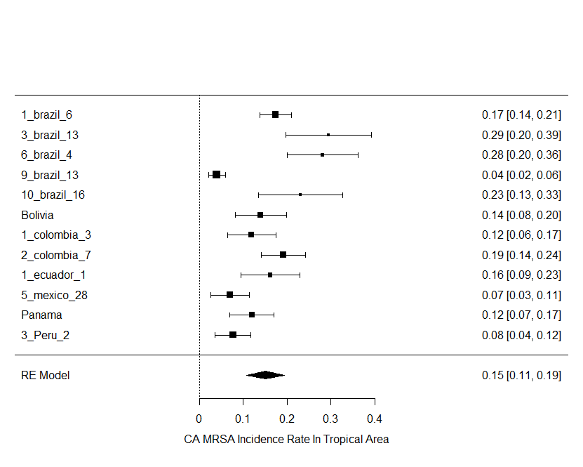 | 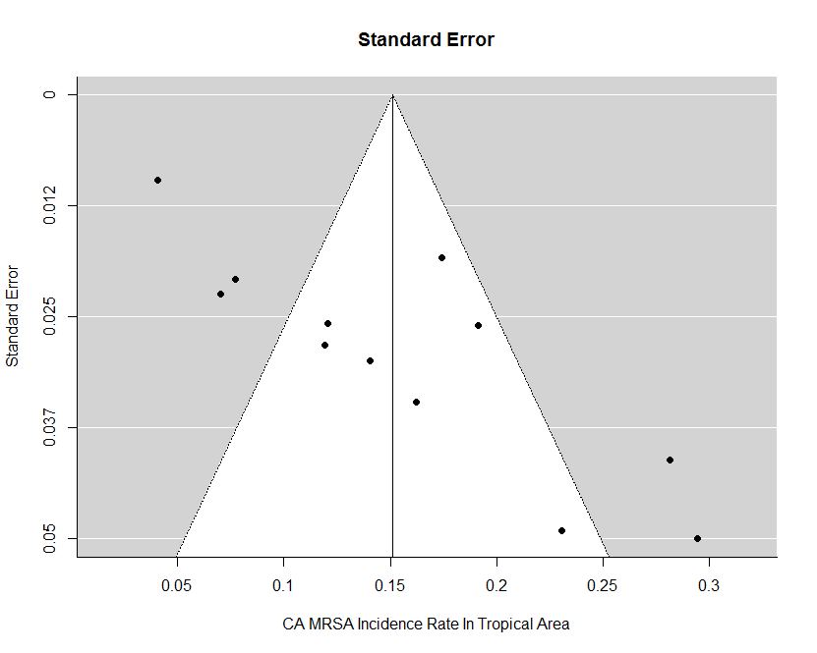
Figure 8: CA MRSA Prevalence Tropical | Figure 9: CA MRSA Prevalence Tropical
Fixed-Effects Model (k = 12)
Test for Heterogeneity:
Q (df = 11) = 118.8280, p-val < .0001
Model Results:
estimate se zval pval ci.lb ci.ub
0.1585 0.0092 17.2786 <.0001 0.1405 0.1764 ***

Random-Effects Model (k = 12; tau^2 estimator: REML)
tau^2 (estimated amount of total heterogeneity): 0.0051 (SE = 0.0025)
tau (square root of estimated tau^2 value): 0.0711
I^2 (total heterogeneity / total variability): 90.30%
H^2 (total variability / sampling variability): 10.31
Test for Heterogeneity:
Q (df = 11) = 118.8280, p-val < .0001
Model Results:
estimate se zval pval ci.lb ci.ub
0.1510 0.0223 6.7677 <.0001 0.1073 0.1948 ***

Table 8: CA Prevalence Rates Tropical

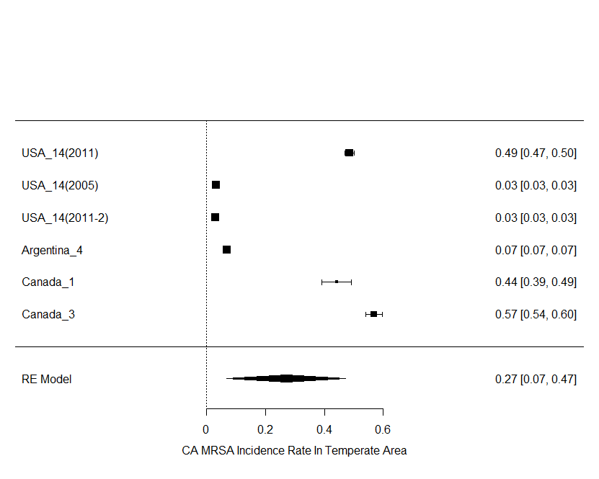 | 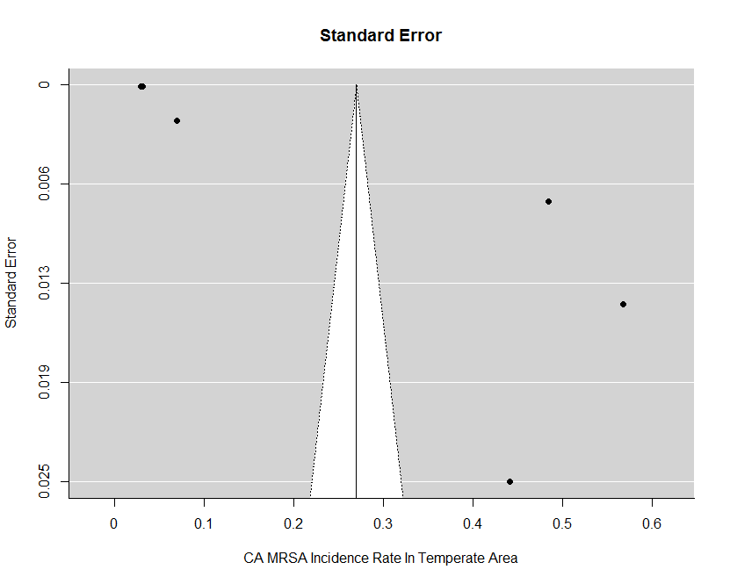
Figure 10: CA MRSA Prevalence Temperate | Figure 11: CA MRSA Prevalence Temperate
Fixed-Effects Model (k = 6)
Test for Heterogeneity:
Q (df = 5) = 5909.3837, p-val < .0001
Model Results:
estimate se zval pval ci.lb ci.ub
0.2709 0.0050 53.9473 <.0001 0.2610 0.2807 ***

Random-Effects Model (k = 12; tau^2 estimator: REML)
tau^2 (estimated amount of total heterogeneity): 0.0638 (SE = 0.0404)
tau (square root of estimated tau^2 value): 0.2525
I^2 (total heterogeneity / total variability): 100.00%
H^2 (total variability / sampling variability): 913300.84
Test for Heterogeneity:
Q (df = 5) = 5909.3837, p-val < .0001
Model Results:
estimate se zval pval ci.lb ci.ub
0.2704 0.1032 2.6197 0.0088 0.0681 0.4727 **

Table 9: CA Prevalence Temperate

Tropical HA MRSA Rate
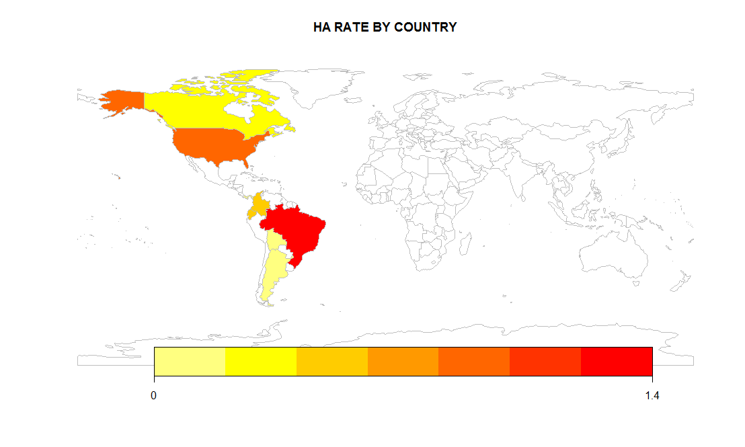
Hospital acquired prevalence statistics of MRSA showed that the prevalence rate in tropical countries was 41% (z-value:38.2, p-value < 0.0001) and 41% (z-value:3.80, p-value < 0.0001) for fixed and random effects model respectively while temperate countries presented 25% (z-value:85.4, p-value < 0.0001) and was 25% (z-value:2.32, p-value: 0.0198).

Figure 12: HA-MRSA Prevalence Map

 | Brazil | Bolivia | Colombia | Ecuador | Panama | USA | Argentina | Canada
Avg. Prev. | 0.2511 | 0.0179 | 0.0237 | 0.4697 | 0.0132 | 0.2862 | 0.0020 | 0.1826
# Screened | 4289 | 280 | 688 | 342 | 379 | 35935207 | 47329 | 254900
# S.aureus | 695 | 41 | 469 | 132 | N/A | 1517471 | 1219 | 1482
Table10: HA-MRSA Prevalence

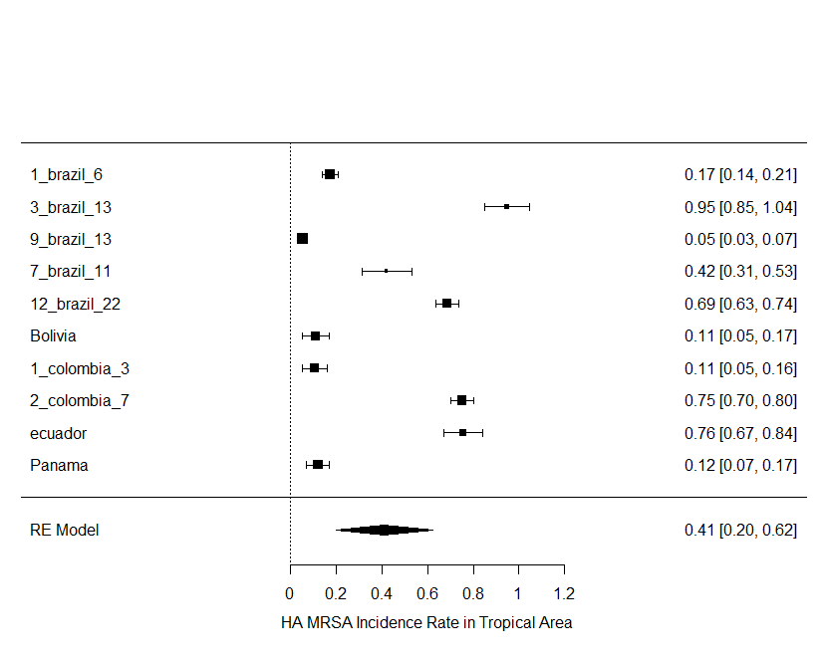 | 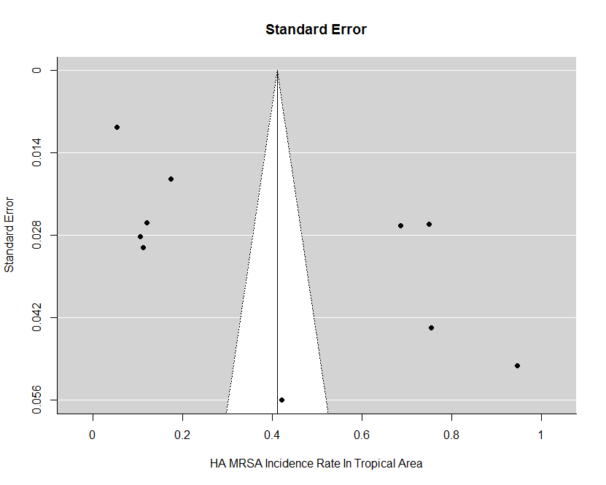
Figure 13: HA MRSA Prevalence Tropical | Figure 14: HA MRSA Prevalence Tropical
Fixed-Effects Model (k = 10)
Test for Heterogeneity:
Q(df = 9) = 1469.6102, p-val < .0001
Model Results:
estimate se zval pval ci.lb ci.ub
0.4122 0.0108 38.2728 <.0001 0.3911 0.4333 ***

Random-Effects Model (k = 10; tau^2 estimator: REML)
tau^2 (estimated amount of total heterogeneity): 0.1152 (SE = 0.0549)
tau (square root of estimated tau^2 value): 0.3395
I^2 (total heterogeneity / total variability): 99.51%
H^2 (total variability / sampling variability): 202.85
Test for Heterogeneity:
Q(df = 9) = 1469.6102, p-val < .0001
Model Results:
estimate se zval pval ci.lb ci.ub
0.4109 0.1079 3.8084 0.0001 0.1994 0.6223 ***

Table 11: HA Prevalence Temperate

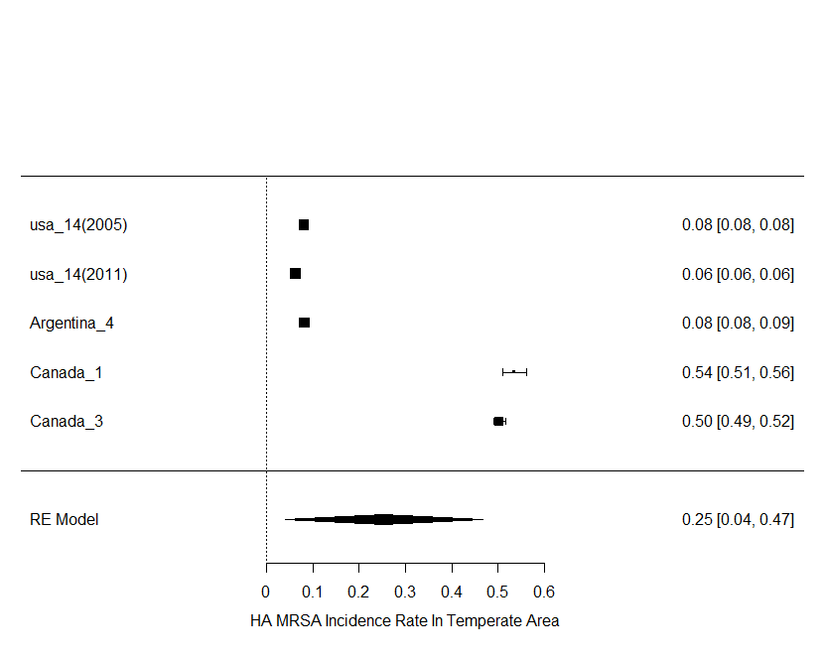 | 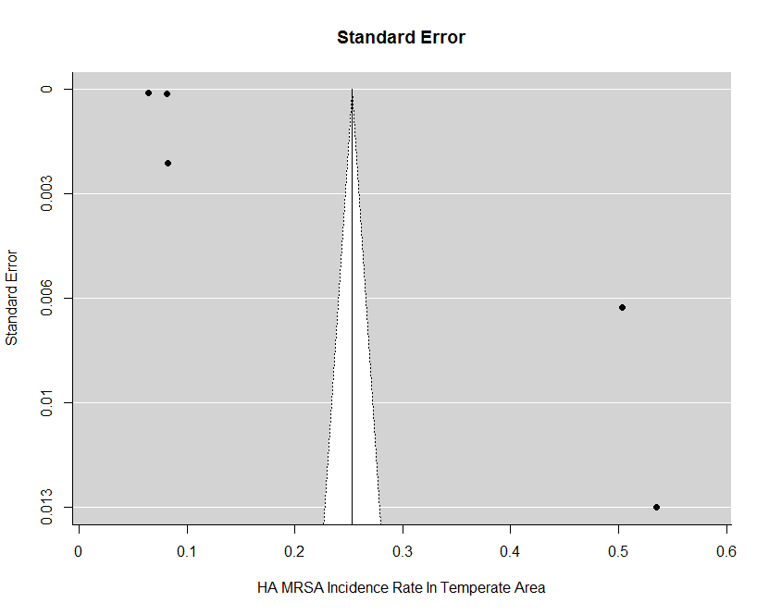
Figure 15: HA MRSA Prevalence Temperate | Figure 16: HA MRSA Prevalence Temperate
Fixed-Effects Model (k = 5)
Test for Heterogeneity:
Q(df = 4) = 16508.4839, p-val < .0001
Model Results:
estimate se zval pval ci.lb ci.ub
0.2533 0.0030 85.4093 <.0001 0.2475 0.2591

Random-Effects Model (k = 5; tau^2 estimator: REML)
tau^2 (estimated amount of total heterogeneity): 0.0590 (SE = 0.0417)
tau (square root of estimated tau^2 value): 0.2429
I^2 (total heterogeneity / total variability): 100.00%
H^2 (total variability / sampling variability): 1056275.79
Test for Heterogeneity:
Q(df = 4) = 16508.4839, p-val < .0001
Model Results:
estimate se zval pval ci.lb ci.ub
0.2531 0.1087 2.3292 0.0198 0.0401 0.4661

Table 12: HA MRSA Prevalence Temperate

DISCUSSION
Worldwide, the prevalence rate of decline of MRSA can be divided into 3 main zones: Asia and America (low decline), East Europe (intermediate decline) and Western Europe (high decline).^{3,30} The data presented in this study contributes to the economic and climatic analysis of the MRSA infection. Since countries with a warmer climate are more prone to the infection and less likely to contain MRSA, the division of tropical and temperate zones of America present a unique insight towards epidemiologic implications of MRSA.³¹
McBride et al. addressed that humidity promotes hydration of the skin especially through the stratum corneum which in turn promotes microbial growth.³²⁻³⁴ Since, most tropical countries report high relative humidity and high temperature in comparison to temperate zones, it can be safely assumed that high sweat production and high environmental humidity enhances S. aureus and MRSA transmission, colonization and infection due to promotion of microbial colonies on the intact and non-intact skin as well as peripheral openings in the body.³⁵ Likewise, increased MRSA transmission in tropical regions of America may reflect a higher frequency of MRSA colonies on the skin, throat, nares and perineum in hot and humid conditions.^{34,36,37} Mermel et al. reported seasonal surge of MRSA infections during warm months of the year and reported that higher CA-MRSA and HA-MRSA prevalence is observed in the second two quarters of the year. They also reported that pediatric patients experience a substantial rise in prevalence rates during the warmer seasons.²⁰ Sahoo et al reported that temperature above 33 °C and an average relative humidity range of 55%-78% presents higher prevalence rates of S. aureus and MRSA associated infections. As per the Koppen climate classifications, tropical countries experience average temperature above 18 °C and average relative humidity (RH) above 60% while temperate climates range between -3 °C and 18 °C with variable RH depending on the season.¹ Therefore, our findings suggest that the significant differences between the temperate and tropical zones of America may be correlated with temperature and relative humidity. These conclusions also assert our climatic and demographic findings in the tropical zone of America where the carriage rate in children was reportedly higher than other age groups. These results are in alignment with Mermel et al who reported three times higher seasonal variation in pediatric patients during warmer seasons than other times of the year.²⁰ However, researchers have also reported that since the prevalence of MRSA infection is seasonal with higher occurrence in 2nd and 3rd quarters of the year, it can also create a bias in data analysis as the studies considered in this review are conducted at various time frames. Likewise, results obtained in this study may be influenced by a seasonal mismatch in temperate and tropical regions should they be conducted in dissimilar seasons. Since information related to seasonal mismatch is not documented and analyzed in this study, it may generate a bias in overall MRSA prevalence rates and underlying CA-MRSA and HA-MRSA interpretations in these climatic zones.^{17,31}
Additional factors contributing towards increased prevalence rates of S. aureus and MRSA are overcrowding, poor hygiene and limited water availability, however, these factors have been studied in accordance with generalized microbial colonization rather than specific MRSA prevalences¹⁸. Likewise, researchers have also associated that since most tropical countries are essentially developing countries, the prevalence of MRSA is higher in these regions especially in children.³⁶
Similarly, Sahoo et al. documented a time series analysis of CA-MRSA prevalence in India and reported the significance of climatic as well as socioeconomic factors for increased prevalence rates.¹⁷ Alternatively, several European based studies have reported a decline of MRSA occurrence in the past decade, which indicates the relatively low prevalence of MRSA in the temperate zone around the world.^{10,16} Moreover, studies have reported that migration may be considered a non-negligible cause of distribution. These epidemiological studies associate MRSA with a higher influence of CA-MRSA and its isolates, describing emergence of higher CA-MRSA cases in countries with more number of tourists, refugees and immigrants.³⁶ However no significant change in prevalence rates is observed with CA-MRSA prevalence rate reported in our studies with 15% (z-value: 6.77, p-value < 0.0001) and 27% (z-value:2.61, p-value: 0.0088) for tropical and temperate countries respectively present indications of possible bias towards the implications of migration of healthcare professionals, pediatrics and general population from tropical countries to temperate countries to misjudge the CA-MRSA occurrence in temperate region.
Furthermore, the emergence of vancomycin resistant MRSA presents a threat to control infection in tropical countries where Panton–Valentine leukocidin (PVL) negative isolates are more commonly observed. Researchers have commented towards the nature of site where the infection has transmitted for such influences. Likewise, in tropical places where airborne infections are highly prevalent, PVL negative strains are difficult to avoid.³¹

Limitations
A major limitation of this review is the limited data obtained from studies assessed for carriage rates of S. aureus and MRSA. A number of studies included achieved a moderate quality level due to which the search strategy was redefined. A large number of studies could not be included due to pooled data for nasal, fecal and throat carriage within and between the healthcare and community settings. Likewise, low socioeconomic countries of South America, especially in the tropical zone, have shown to contribute higher prevalence rates of S. aureus and MRSA, but due to low funding available on reporting through research, several variables are left unchecked. There is a need for generating more sequence base genotyping data on tropical and temperate countries in America and other countries of the world. Also, the fast emergence of American lineage is dependent on multifactorial interactions between host, pathogen and the environment.³⁰ Thus, regular surveillance of CA and HA-MRSA and related antibiotic sensitivity patterns is necessary for the formulation of definite antibiotic policy across America where MRSA decline is happening at a very low rate compared to Asia and Europe. This investigation may facilitate more prompt and effective action for the prevention and control of MRSA infections in tropical countries of the America. In particular, the use of MRSA screening based on rapid and reliable diagnosis during inpatient and outpatient admission is crucial.
Conclusion
This systematic review and meta analysis provides insights on the climatic influence of MRSA due to which countries in tropical zone of America are more vulnerable to MRSA transmission and infection. It also discusses MRSA prevalence rate change due to demographic factors and in states that men are more prone to MRSA carriage than woman and so are the elderly population. The fast emergence of American lineage is dependent on multifactorial interactions between host, pathogen and the environment. Thus, regular surveillance of CA and HA-MRSA and related antibiotic sensitivity patterns is necessary for the formulation of definite antibiotic policy across America where MRSA decline is happening at a very low rate compared to Asia and Europe.
This investigation may facilitate more prompt and effective action for the prevention and control of MRSA infections in tropical countries of the Americas. In particular, the use of MRSA screening based on rapid and reliable diagnosis during inpatient and outpatient admission of patients is crucial.

Future Considerations
Based upon limitations identified during the systematic review and meta analysis, the authors will be exploring various variables and correlations. As an initial effort, chi square tests were performed to check if MRSA prevalence was associated with climate. The analysis revealed a significant association between the climate and MRSA prevalence (χ² = 667, df=3, P<0.05). Chi-square tests between climate and gender wise MRSA prevalence revealed a significant association between gender of MRSA infected patients and climate (χ² = 8608, df=1, P<0.05). The chi-square test between climate and age wise MRSA infections revealed a significant association between age of MRSA infected patients and climate (χ² = 11.65, df=2, P<0.05), Tables 13 – 15.
Climate | S. aureus | CA MRSA | HA MRSA | MRSA Detected | Total
Tropical (observed) | 1693 | 87 | 500 | 587 | 2867
Temperate (observed) | 1526908 | 539475.1 | 325185.9 | 968770.5 | 3360339.4
Total | 1528601 | 539562.1 | 325685.9 | 969357.5 | 3363206.4
Climate | S. aureus | CA MRSA | HA MRSA | MRSA Detected | Total
Tropical (Expected) | 1303.072 | 459.9553 | 277.6343 | 826.3388
(O-E) | 389.9283 | -372.955 | 222.3657 | -239.339
(O-E)2 | 152044.1 | 139095.6 | 49446.52 | 57283.05
(O-E)2/E | 116.6813 | 302.4112 | 178.0995 | 69.32151 | 666.51351
Climate | S. aureus | CA MRSA | HA MRSA | MRSA Detected | Total
Temperate (Expected) | 1527298 | 539102.2 | 325408.2 | 968531.1
(O-E) | -389.928 | 372.9553 | -222.366 | 239.3388
(O-E)2 | 152044.1 | 139095.6 | 49446.52 | 57283.05
(O-E)2/E | 0.099551 | 0.258014 | 0.151952 | 0.059144 | 0.5686611
 |  |  |  | Chi | 667.08217
 |  |  |  | DF | 3
 |  |  |  | Crit | 7.815
 |  |  |  | P | <0.05
Table 13: Chi Square Test Between Climate and S.aureus / MRSA Prevalence

Climate | Male | Female | Total
Tropical (observed) | 189 | 113 | 302
Temperate (observed) | 6546 | 4925 | 11471
Total | 6735 | 5038 | 11773
Climate | Male | Female | Total
Tropical (Expected) | 5.74132 | 4.294695
(O-E) | 183.2587 | 108.7053
(O-E)2 | 33583.74 | 11816.84
(O-E)2/E | 5849.481 | 2751.498 | 8600.979
Climate | Male | Female | Total
Temperate (Expected) | 6729.259 | 5033.705
(O-E) | -183.259 | -108.705
(O-E)2 | 33583.74 | 11816.84
(O-E)2/E | 4.990705 | 2.347544 | 7.338249
 |  | Chi | 8608.317
 |  | DF | 1
 |  | crit | 3.841
 |  | P | <0.05
Table 14: Chi Square Test Between Climate and Gender Wise MRSA Prevalence

Climate | <15 yrs | 15-65 yrs | >65 yrs | Total
Tropical (observed) | 51 | 38 | 42 | 131
Temperate (observed) | 543151.8 | 715228.9 | 838883.8 | 2097265
Total | 543202.8 | 715266.9 | 838925.8 | 2097396
Climate | <15 yrs | 15-65 yrs | >65 yrs | Total
Tropical (Expected) | 33.92758 | 44.67444 | 52.39798
(O-E) | 17.07242 | -6.67444 | -10.398
(O-E)2 | 291.4674 | 44.54811 | 108.118
(O-E)2/E | 8.590867 | 0.997172 | 2.063399 | 11.65144
Climate | <15 yrs | 15-65 yrs | >65 yrs | Total
Temperate (Expected) | 543168.9 | 715222.2 | 838873.5
(O-E) | -17.0724 | 6.674437 | 10.39798
(O-E)2 | 291.4674 | 44.54811 | 108.118
(O-E)2/E | 0.000537 | 6.23E-05 | 0.000129 | 0.000728
 |  |  | Chi | 11.65217
 |  |  | Df | 2
 |  |  | Crit | 5.991
 |  |  | P | <0.05
Table 15: Chi Square Test Between Climate and Gender wise MRSA prevalence

REFERENCES
- Peel MC, Finlayson BL, Mcmahon TA. Updated world map of the Köppen-Geiger climate classification. Hydrology and Earth System Sciences Discussions, European Geosciences Union. 2007;11(5):1633-1644. doi:10.5194/hess-11-1633-2007.
- Moore M. Staph antibiotics: a brief overview. Staph-Infection-Resources. https://www.staph-infection-resources.com/treatment/conventional/staph-antibiotics/. Accessed April 1, 2018.
- Walraven CJ, North MS, Marr-Lyon L, Deming P, Sakoulas G, Mercier R-C. Site of infection rather than vancomycin MIC predicts vancomycin treatment failure in methicillin-resistant Staphylococcus aureus bacteraemia. Journal of Antimicrobial Chemotherapy. 2011;66(10):2386–2392. doi:10.1093/jac/dkr301.
- Dengremont E, Membré JM. Statistical approach for comparison of the growth rates of five strains of Staphylococcus aureus. Applied and Environmental Microbiology. 1995;61(12):4389-4395. http://aem.asm.org/content/61/12/4389.full.pdf+html. Accessed March 26, 2018.
- Todar K. Growth of Bacterial Populations. In: Todar K, ed. Todar’s Online Textbook of Bateriology. Madison, WI: 2008-2012: http://textbookofbacteriology.net/growth_3.html : Accessed March 31, 2018.
- Michels H, Noyce J, Keevil C. Effects of temperature and humidity on the efficacy of methicillin-resistant Staphylococcus aureus challenged antimicrobial materials containing silver and copper. Letters in Applied Microbiology. 2009;49(2):191-195. doi:10.1111/j.1472-765X.2009.02637.x.
- Masalha M, Borovok I, Schreiber R, Aharonowitz Y, Cohen G. Analysis of Transcription of the Staphylococcus aureus Aerobic Class Ib and Anaerobic Class III Ribonucleotide Reductase Genes in Response to Oxygen. Journal of Bacteriology. 2001;183(24):7260–72. doi:10.1128/JB.183.24.7260-7272.2001.
- Ogston A. Report upon Micro-Organisms in Surgical Diseases. British Medical Journal. 1881;1(1054):369.b2-375.https://www.ncbi.nlm.nih.gov/pmc/articles/PMC2263466/pdf/
brmedj05004-0001.pdf. Accessed April 9, 2018.
- Voss A, Doebbeling BN. The worldwide prevalence of methicillin-resistant Staphylococcus aureus. International Journal of Antimicrobial Agents. 1995;5(2):101–6. doi:10.1016/0924-8579(94)00036-T.
- Schaumburg F, Köck R, Mellmann A, Richter L, Hasenberg F, Roembke F, Kriegeskorte A, Friedrich A, Gatermann S, Peters G, von Eiff C, Becker K. (2012). Population Dynamics among Methicillin-resistant Staphylococcus aureus Isolates in Germany during a 6-Year Period. Journal of clinical microbiology. 2012;50(10):3186-92. doi:10.1128/JCM.01174-12.
- Orrett FA, Land M. Methicillin-resistant Staphylococcus aureus prevalence: Current susceptibility patterns in Trinidad. BMC Infectious Diseases. 2006;6:83. doi:10.1186/1471-2334-6-83.
- Tong SY, Davis JS, Eichenberger E, Holland TL, Fowler VG. Staphylococcus aureus infections: epidemiology, pathophysiology, clinical manifestations, and management. Clinical Microbiology Reviews. 2015;28(3):603-61. doi:10.1128/CMR.00134-14.
- Stryjewski ME, Corey GR. Methicillin-resistant Staphylococcus aureus: an evolving pathogen. Clinical Infectious Diseases. 2014;58(Suppl 1):S10-S19. doi:10.1093/cid/cit613.
- Gallagher R, Motohashi N, Vanam A, et al. Global methicillin-resistant Staphylococcus aureus (MRSA) infections and current research trends. Arch Gen Intern Med. 2017;1(2):3-11. http://www.alliedacademies.org/articles/global-methicillinresistant-staphylococcus-aureus-mrsa-infections-and-current-research-trends.html. Accessed April 17, 2017.
- Suaya JA, Cassidy A, Meera RM, O’Hara P, Amrine-Madsen H, Burstin S, Miller LG. Incidence and cost of hospitalizations associated with Staphylococcus aureus skin and soft tissue infections in the United States from 2001 through 2009. BMC Infect Diseases. 2009;14(296). doi:10.1186/1471-2334-14-296.
- Köck R1, Becker K, Cookson B, van Gemert-Pijnen JE, Harbarth S, Kluytmans J, Mielke M, Peters G, Skov RL, Struelens MJ, Tacconelli E, Navarro Torné A, Witte W, Friedrich AW. Methicillin-resistant Staphylococcus aureus (MRSA): burden of disease and control challenges in Europe. Euro Surveillance. 2010;15(41):19688. doi:10.2807/ese.15.41.19688-en.
- Sahoo KC, Sahoo S, Marrone G, Pathak A, Lundborg CS, Tamhankar AJ. Climatic Factors and Community - Associated Methicillin-resistant Staphylococcus aureus Skin and Soft-Tissue Infections - A Time-Series Analysis Study. International journal of environmental research and public health. 2014;11(9):8996-9007. doi:10.3390/ijerph110908996.
- Tong SY, Steer AC, Jenney AW, Carapetis JR. Community-associated Methicillin-resistant Staphylococcus aureus Skin Infections in the Tropics. Dermatologic clinics. 2011;29(1):21-32. doi:10.1016/j.det.2010.09.005.
- Delorme T, Garcia A, Nasr P. A longitudinal analysis of methicillin-resistant and sensitive Staphylococcus aureus incidence in respect to specimen source, patient location, and temperature variation. International Journal of Infectious Diseases. 2017;54:50–57. doi:10.1016/j.ijid.2016.11.405.
- Mermel LA, Machan JT, Parenteau S. Seasonality of MRSA infections. PLoS One. 2011;6(3):e17925. doi:10.1371/journal.pone.0017925.
- Nickerson EK, Hongsuwan M, Limmathurotsakul D, Wuthiekanun V, Shah KR, Srisomang P, Mahavanakul W, Wacharaprechasgul T, Jr VGF, West TE, Teerawatanasuk N, Becher H, White NJ, Chierakul W, Day NP, Peacock SJ. Staphylococcus aureus bacteraemia in a tropical setting: patient outcome and impact of antibiotic resistance. PLoS One. 2009;4(1):e4308. doi:10.1371/journal.pone.0004308.
- Zulkeflle SN, Yusaimi YA, Sugiura N, Iwamoto K, Goto M, Utsumi M, Othman NB, Zakaria Z, Hara H. Phenotypic and genetic characterization of multidrug-resistant Staphylococcus aureus in the tropics of Southeast Asia. Microbiology Society Journal. 2016;162(12):2064–2074. doi:10.1099/mic.0.000392.
- Mabey D, Peeling RW, Ustianowski A, Perkins M. Tropical infectious diseases: Diagnostics for the developing world. Nature Reviews Microbiology. 2004;2:231. doi:10.1038/nrmicro841.
- Moher D, Liberati A, Tetzlaff J, Altman DG; Prisma Group. Preferred reporting items for systematic reviews and meta-analyses: the PRISMA statement. PLoS Medicine. 2009;6(7):e1000097. doi:10.1371/journal.pmed.1000097.
- Rafiq M, Boccia S. Application of the GRADE Approach in the Development of Guidelines and Recommendations in Genomic Medicine. Genomics Insights. 2018;11:1178631017753360. doi:10.1177/1178631017753360.
- Chiolero A, Santschi V, Burnand B, Platt RW, Paradis G. Meta-analyses: with confidence or prediction intervals. European journal of epidemiology. 2012;27(10): 823–5. doi:10.1007/s10654-012-9738-y.
- Longtin Y, Sudre P, Francois P, Schrenzel J, Aramburu C, Pastore R, Gervaix A, Renzi G, Pittet D, Harbarth S. Community-associated methicillin-resistant Staphylococcus aureus: risk factors for infection, and long-term follow-up. Clinical Microbiology and Infection. 2009;15(6):552–559. doi:10.1111/j.1469-0691.2009.02715.x.
- Mediavilla JR, Chen L, Mathema B, Kreiswirth BN. Global epidemiology of community-associated methicillin resistant Staphylococcus aureus (CA-MRSA). Current Opinion in Microbiology. 2012;15(5):588–595. doi:10.1016/j.mib.2012.08.003.
- Stefani S, Chung DR, Lindsay JA, Friedrich AW, Kearns AM, Westh H, MacKenzie F. Meticillin-resistant Staphylococcus aureus (MRSA): global epidemiology and harmonisation of typing methods. International Journal of Antimicrobial Agents. 2012;39(4):273–282. doi:10.1016/j.ijantimicag.2011.09.030.
- Thurlow LR, Joshi GS, Richardson AR. Virulence strategies of the dominant USA300 lineage of community‐associated methicillin‐resistant Staphylococcus aureus (CA‐MRSA). Pathogens and Disease. 2012;65(1):5–22. doi:10.1111/j.1574-695X.2012.00937.x.
- Rodríguez-Noriega E, Seas C, Guzman-Blanco M, Mejía C, Alvarez C, Bavestrello L, Zurita J, Labarca J, Luna C, Salles M, Gotuzzo E. Evolution of methicillin-resistant Staphylococcus aureus clones in Latin America. International Journal of Infectious Diseases. 2010;14(7):e560–e566. doi:10.1016/j.ijid.2009.08.018.
- McBride ME, Duncan WC, Knox J. The environment and the microbial ecology of human skin. Applied and Environmental Microbiology. 1977;33(3):603–608. https://scinapse.io/papers/1693205652. Accessed April 12, 2018.
- Singh G. Heat, humidity and pyodermas. Dermatology 1973;147:342–7. doi:10.1159/000251891
- Leekha S, Diekema D, Perencevich E. Seasonality of staphylococcal infections. Clinical Microbiology and Infection. 2012;18(10):927–33. doi:10.1111/j.1469-0691.2012.03955.x.
- Ruiz ME, Yohannes S, Wladyka CG. Pyomyositis caused by methicillin-resistant Staphylococcus aureus. New England Journal of Medicine. 2005;352(14):1488–9. doi:10.1056/NEJM200504073521417.
- Herrmann M, Abdullah S, Alabi A, Alonso P, Friedrich AW, Fuhr G, Germann A, Kern WV, Kremsner PG, Mandomando I, Mellmann AC, Pluschke G, Rieg S, Ruffing U, Schaumburg F, Tanner M, von Briesen H, von Eiff C, von Mueller L, Grobusch MP. Staphylococcal disease in Africa: another neglected “tropical” disease. Future Microbiology. 2013;8(1):17–26. doi:10.2217/fmb.12.126.
- Cochran WG. The Comparison of Percentages in Matched Samples. Biometrika. 1950;37(3-4):256–266. doi:10.1093/biomet/37.3-4.256.

